MOWW JROTC Award of Merit
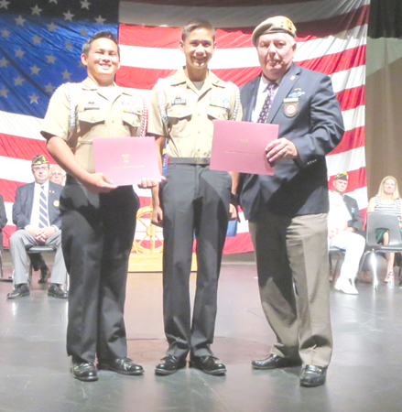
The Gen JP Holland Chapter provides and presents the JROTC Certificate and Medal of Merit to three NJROTC Units in our local area. The following Naval Cadets received the Medal of Merit and Certificate:
Westview HS NJROTC – June 8, 2014 – Presented by Andre LeCault
Cadet Commander Tyler Pacrem
Cadet MCPO Steven Conde
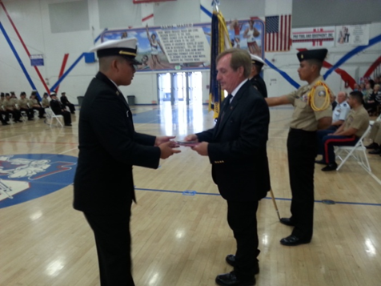
Orange Glen HS NJROTC May 23, 2014 - Presented by Nick Herbka
Cadet Commander Genaro Hernandez
Ramona HS NROTC – May 17,2014 – Presented by Tom Morgan
Cadet PO2 Erik Hietala
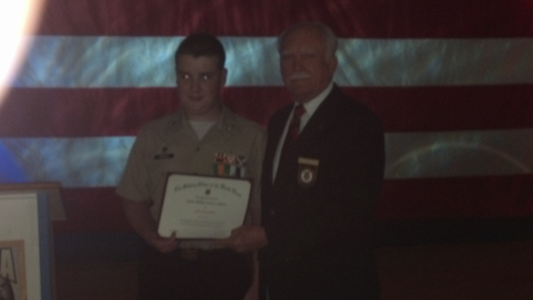 Ramona HS NJROTC – May 17, 2014
Cadet PO2 Erik Hietala Presented by Tom Morgan
Next year our Chapter plans to increase the number of JROTC Awards
given to high achieving Cadets.

